**National College of Science &**

**Information Technology, Bahawalpur**



**Software Design Description Document**

**For**

**Employee Management System**

**By**

**Muhammad Aqib Bhatti**

**Roll No# 180418**

**Program – MCS**

**Semester – 3rd**

**Session 2018-2020**



**IN THE NAME OF ALMIGHTY ALLAH**

**THE MOST BENEFICENT, COMPASSIONATE**

**AND THE MOST MERCIFUL**

**DEDICATION**

TO,

Allah PAAK who has blessed me such people who always paved the way for me to go a step ahead. My Loving Family and Teachers

Whose Support Always gave me the Strength to Accomplish My Goal.

**Revision History**

|  |  |  |  |
| --- | --- | --- | --- |
| Date | Description | Author | Comments |
| <08/11/2020> | <Version 1> | <M.Aqib Bhatti> | <My final MCS Project> |
|  |  |  |  |
|  |  |  |  |
|  |  |  |  |

**Document Approval**

The following Software Requirements Specification has been accepted and approved by the following:

|  |  |  |  |
| --- | --- | --- | --- |
| Signature | Printed Name | Title | Date |
|  |  |  | <02/04/2021> |
|  |  |  |  |
|  |  |  |  |

**Table of Contents**

**1. INTRODUCTION** 2

1.1 Purpose 3

1.2 Scope 4

1.3 Overview 4

1.4 Reference Material 5

1.5 Definitions and Acronyms 6

**2. SYSTEM OVERVIEW** 8

**3. SYSTEM ARCHITECTURE** 12

3.1 Architectural Design 13

3.2 Decomposition Description 14

3.3 Design Rationale 16

**4. DATA DESIGN** 18

4.1 Data Description 19

4.2 Data Dictionary 20

**5. COMPONENT DESIGN** 26

**6. HUMAN INTERFACE DESIGN** 28

6.1 Overview of User Interface 29

6.2 Screen Images 30

**7. REQUIREMENTS MATRIX** 38

* **INTRODUCTION**

Employee Management System(EMS) is a web based application, developed to maintain the details of employees working in any organization. The EMS has been developed to override the problems prevailing in the practicing manual system. It maintains the information about the personal and official details of the employees.

* **Purpose**

This project aims to simplify the task of maintaining records of the employees of Company. To develop a well-designed database to store employee information Provides full functional reports to management of Company. The objective of this project is to provide a comprehensive approach towards the management of employee information. The records are maintained in registers. Time consuming process. Complicated searching, editing & updating. Helps in maintaining the computerized employee details. Calculate the salary. Easy attendance marking. Easy calculation of various leave in categories. Computerized Events & Requests Management. Create new users to the system accordingly.

* **Scope**

The scope of this project will be limited to the following:

Employees will have access to their personal profiles and will be able to edit their details. Employee can ask leave. Employee can check is work detail. Admin can assign task to employees. Admin can approve leaves .Admin manage details of employees. Login Authenticate User. The scope of this project is to perform all the task of employee within an organization in a digital form so that taking any decisions for company owner becomes easier.

* **Overview**

Helps in maintaining the computerized employee details. Calculate the salary. Easy calculation of various leaves in categories. Computerized Events & Requests Management. Create new users to the system accordingly .Because of digital world it would be easy and efficient way of storing and manipulating records of employee in a organization rather than that old manual system which is slow and less efficient.

**Reference Material**

[www.google.com](http://www.google.com/)

[www.slideshare.com](http://www.slideshare.com/)

[www.youtube.com](http://www.youtube.com/)

<https://en.wikipedia.org/wiki/Firefox>

<https://en.wikipedia.org/wiki/Java_(programming_language)>

**Definitions and Acronyms**

|  |  |
| --- | --- |
| **Term** | **Description** |
| Admin | Administrator |
| SDD | Software Design Description |
| Org | Organization |
| EMS | Employee Management System |

* **SYSTEM OVERVIEW**

Nowadays, Employee Management System is being adopted by many sectors in the real world whether it is small or large scale. But currently most of the organizations still using old manual systems and they do not have this system implement to the website. Thus, the I decided to develop a web-based employee management system for organization. The system will be built consists of human resource management function such as leave request, employee report and job application, this function will be integrated to this web-based system. The aim of this project is to design and develop a web based Employee Management System using Java EE and MySQL.

In this project, a web-based Employee Management System will be developed for Bhatti Group of company to manage employee job information, working schedule, leave request, employee report on achievement, training and evaluations. In addition the system will also manage the records of all employees so that records can be easily maintained.

In this web-based system basically it has 2 main users that are administrator, employee. For employee and administrator they can login to the system through online to perform their different task respectively that available for them. Where Admin can do managerial work such as view/modify/create employee report, in addition it also can approve/deny/view leave request, accept/decline/view interview for job candidate, search for employee information and modify/view employee schedule.

In employee, it can request leave and check for leave request whether their leave is approve or deny. Employee also can view working schedule that has been arrange by the manager and search for colleague to view their basic information.

Administrator has just a small task such as create new user if there is any new employee, manager and administrator. In addition, it also can modify user information and delete user, and download doc file that uploaded by the manager to update the require information.

This web-based system is important where it can improve the way of managing and keep track of employee information such as leave request, employee performance report and others. Thus, this can determine the success level of the Bhatti Group of company.

**1-Company Background**

Bhatti Group of company is one of the best company in Pakistan, located at I-14,Islamabad which founded in the year of 2008. This business firm is relatively unique with respect to other business firms because of number of employees.. The Company has a traditional way and manual system of managing their employee information, hence the Company itself has the intention to improve the management of their employee.

**2-Problem Statement**

One of the problems of the current Bhatti Group of company is, they still using the manual way of managing the employee information and records, in term of keeping employee information such as employee leave request, employee report, and employee working schedule. The existing management task on keeping employee records and information of the still has to be done manually by hand written and record it in paper document. Employee records is not always reliable because is it hand written and might cause human error for example manager might write a wrong title in a report. Data duplication problem might happen when manager can’t find require information. There is a possibility that data might get misplace when doing manual filling.

**3-Objective**

The main objective of this project is to develop a web-based employee management system for Bhatti Group of company. The project objective is important because it define the purpose of the project. William (2009) identifies one of the reasons of project objective: “They help frame the project. If you know the project objectives, you can determine the deliverables needed to achieve the objectives.”

The objectives of this project are as shown below:

To understand and defining the Bhatti Group of company for an employee management system.

This objective is to ensure the greater understanding of Bhatti Group of company when developing an employee management system.

To analyses and designing a database suitable for the Bhatti Group of company.

This objective is crucial because it serve as a mainstay of the employee management system.

**3. SYSTEM ARCHITECTURE**

**3.1 Architectural Design**

⦁It described that how to develop a Web project structure and their relationships between the web pages(jsp) and servlets to achieve the complete functionality of the system. This is a high level overview of how responsibilities of the system and subsystems. Each high level subsystem and the roles or responsibilities assigned to it. Additionally, the results of an example of EMS for a business firms are presented using the proposed architecture. These systems are becoming more and more important because of the development in the world. Every company wants a secure system.

⦁ Java EE will be used to develop this projects many servlets and jsps files will be used to create this projects. Servlets will be responsible for accepting the GET and POST request. One can use servlets and jsps to view their tasks accordingly. The user whether admin or Employee will use the system to perform their tasks with the help of java EE technology, Which is based servlets api and jsp pages.

⦁ Look up information — This system can take information form Html forms.

⦁ Generate Response — This system can generate response on a web page in form of table or cards.

⦁ Coordinate effort —It can speed up the company routine of dealing with employee records.

**Physical view of Architecture design**

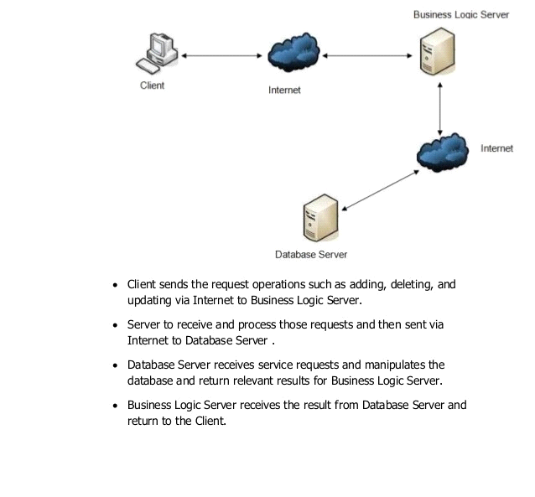

**3.2 Data Flow Diagram**

**DFD Level 0**

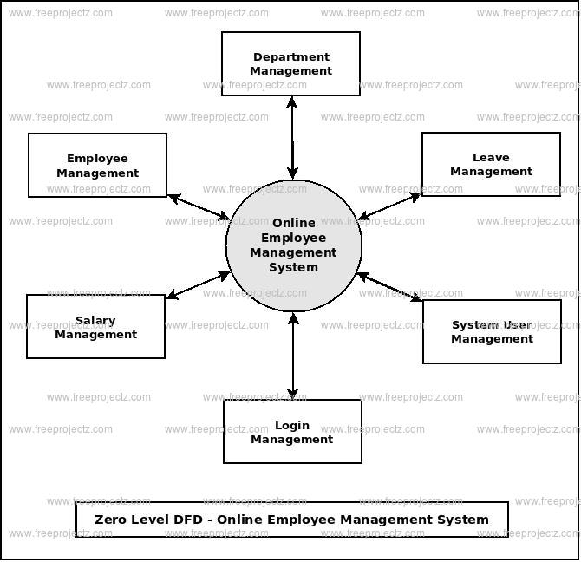

**DFD Level 1**

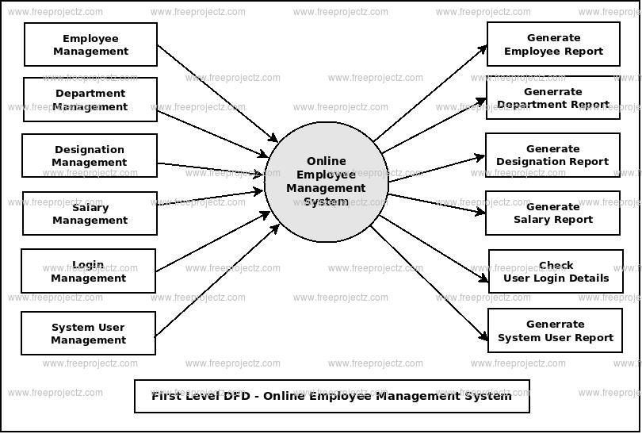

**3.3 Decomposition Description**

This programming in spite of will be client interface nothing. Yet all the at present it might require a login around situated up, with the goal that those outer danger wont botch those quick nourishment frameworks spared amount or those subscriber’s rundown.

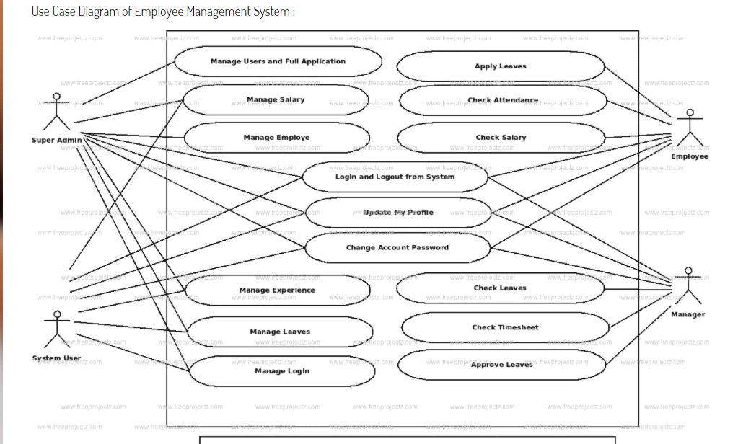

**3.4 Design Rationale**

An EMS with the help of which you can automate the operations u want to perform on a company. It will help to perform all tasks like adding new employee deleting employee, marking attendence,etc.

**4. DATA DESIGN**

**4.1 Data Description**

**4.1.1 Data Objects**

**User:**

**ID:** This is the id of user.

**Username:** This is the username of user.

**Email:** This is the email of user.

**Password:** This is the password of user.

**pic:** This is the image of user.

**about:** This is the about of user.

**time:** This is the time user data was added.

**Employee:**

**ID:** This is the id of employee.

**Ename:** This is the ename of employee.

**Employee email:** This is the email of employee.

**Password:** This is the password of employee.

**pic:** This is the image of employee.

**about:** This is the about of employee.

**time:** This is the time at which employee added.

**Department:**

**D_ID:** This is the id of employee.

**D_name:** This is the name of department.

**D_picture:** This is the email of department.

**D_description:** This is the description of department.

**time:** This is the time at which Department added.

**4.1 Data Description**

**User Table:**

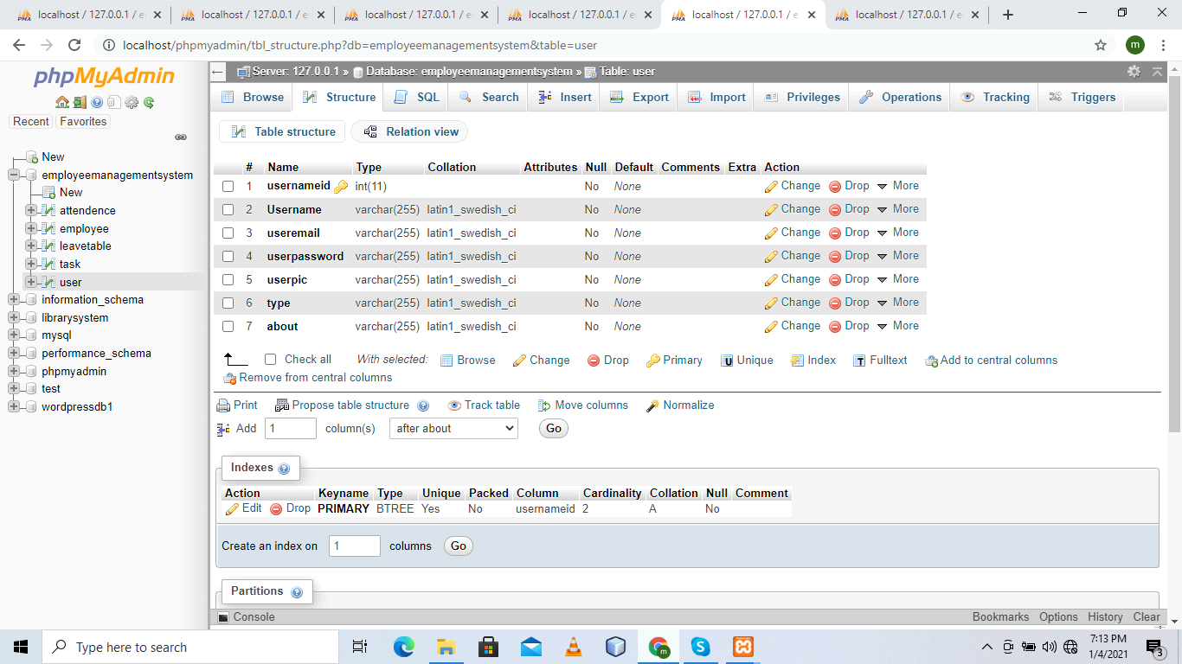

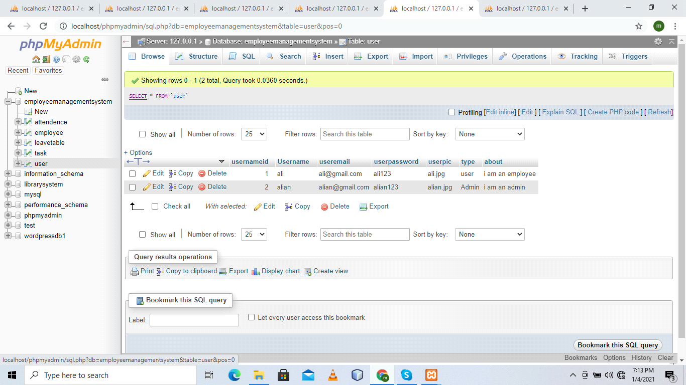

**Attendance Table:**

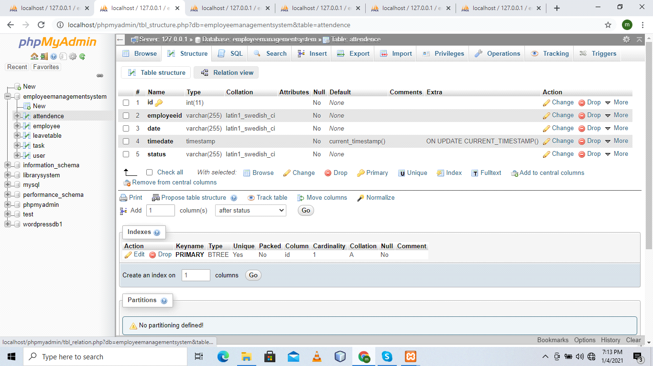

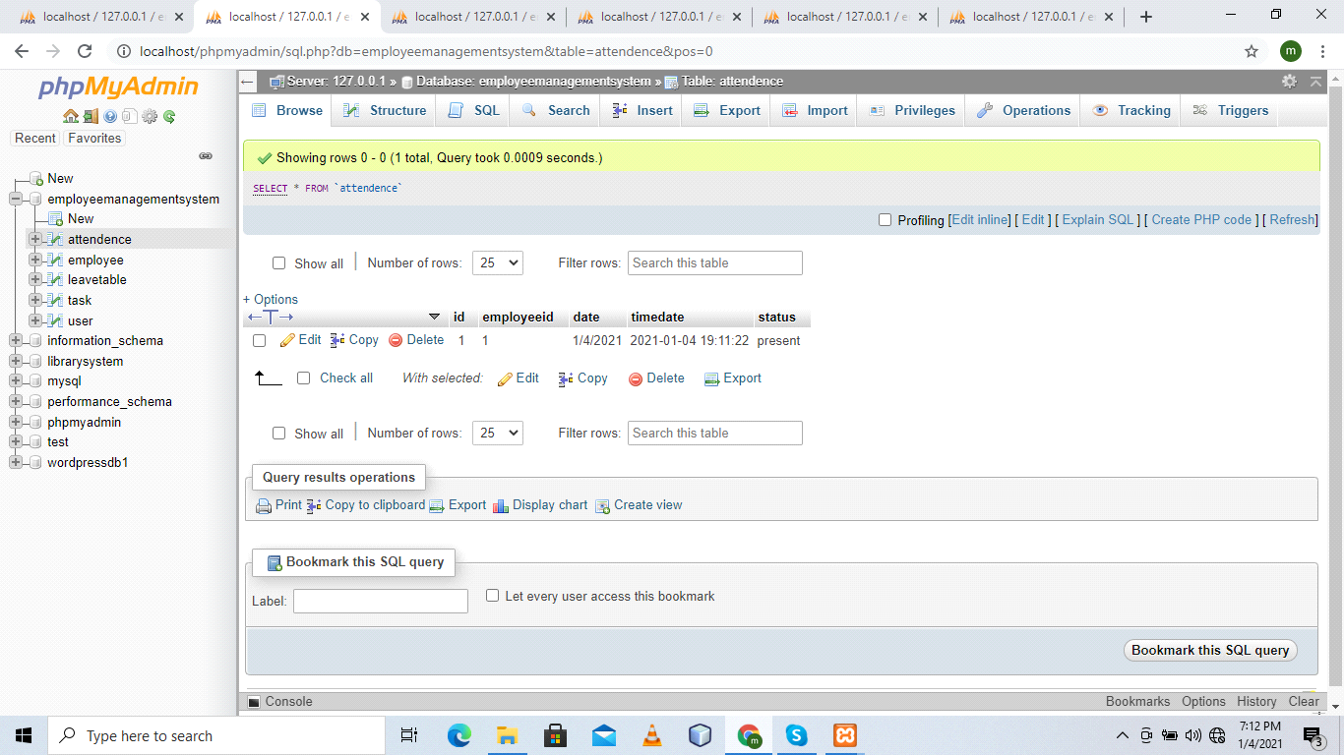

**Employee Table:**

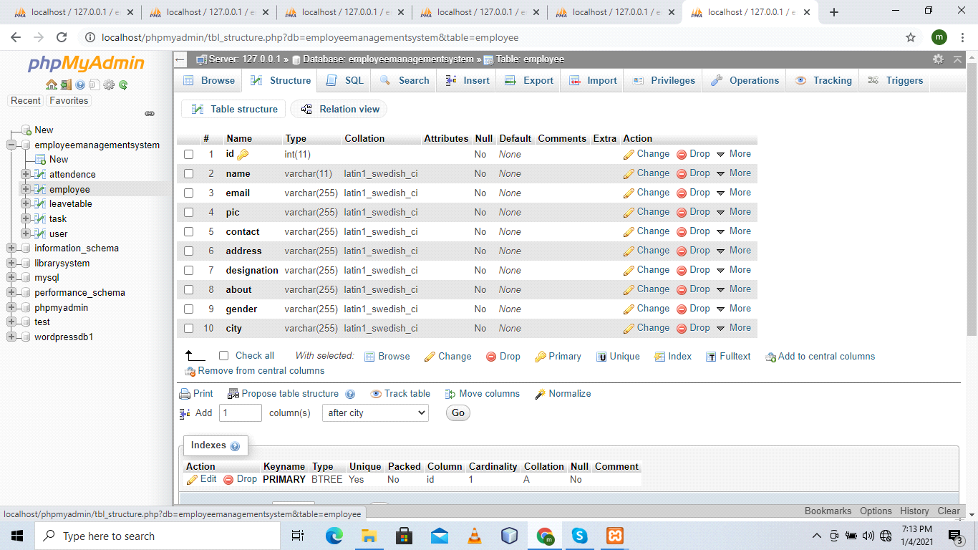

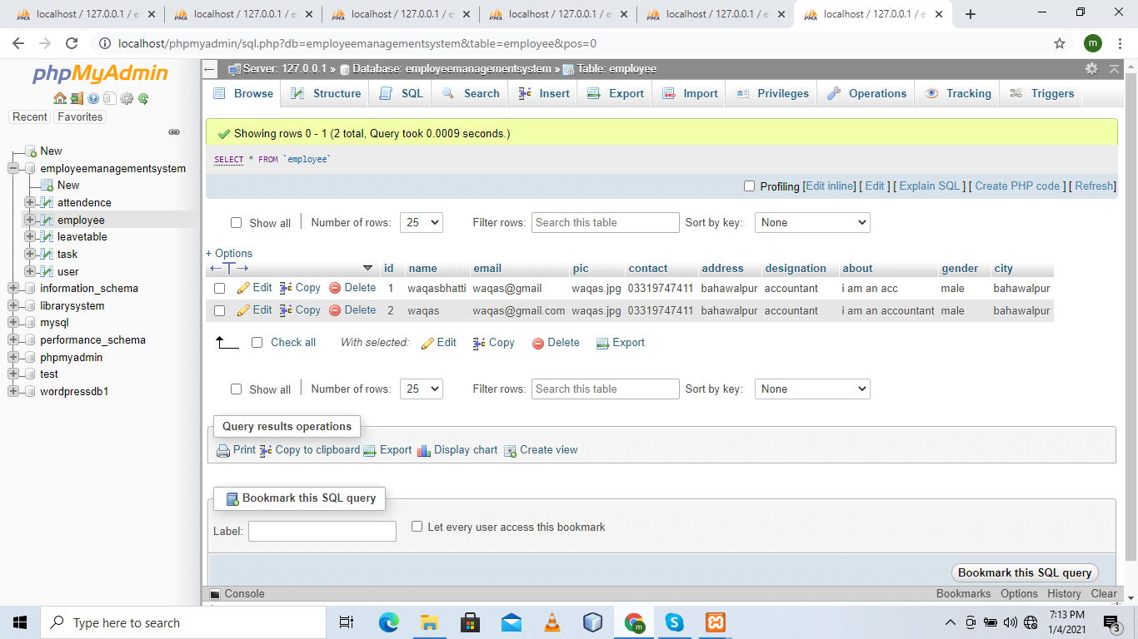

.

**Leave Table:**

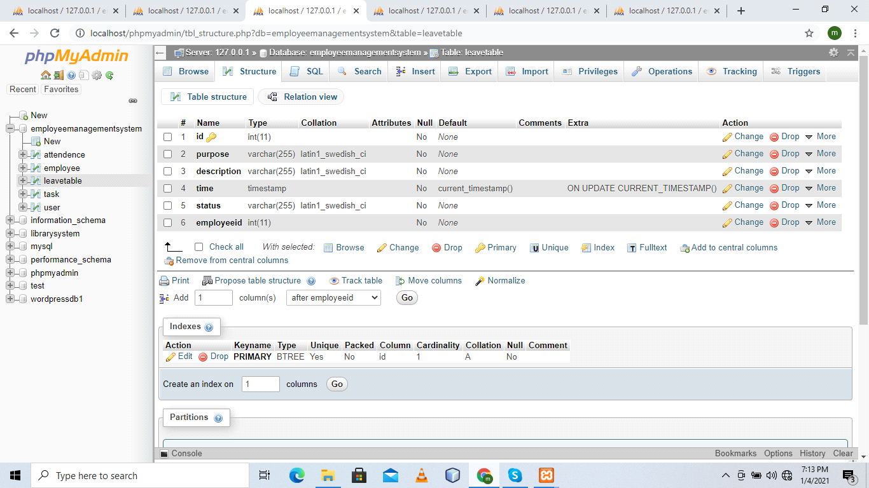

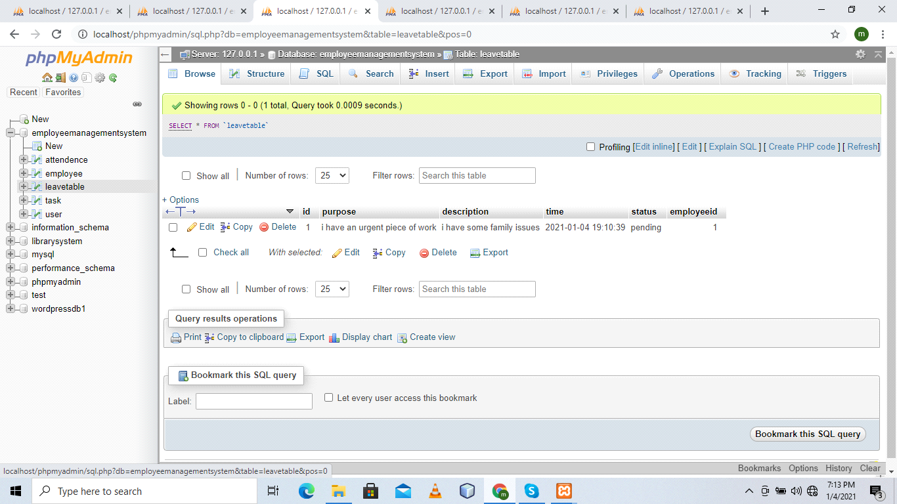

**Task Table:**

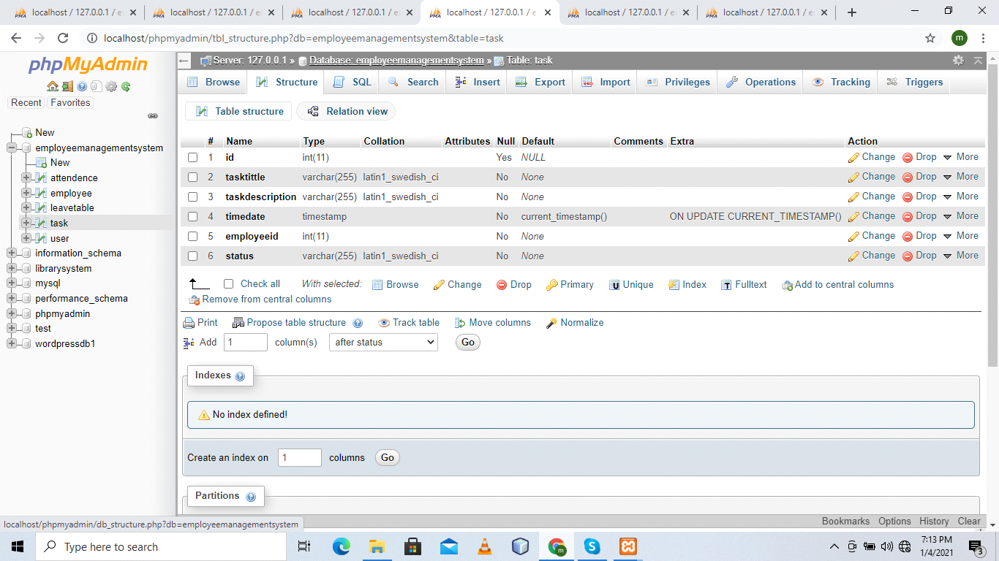

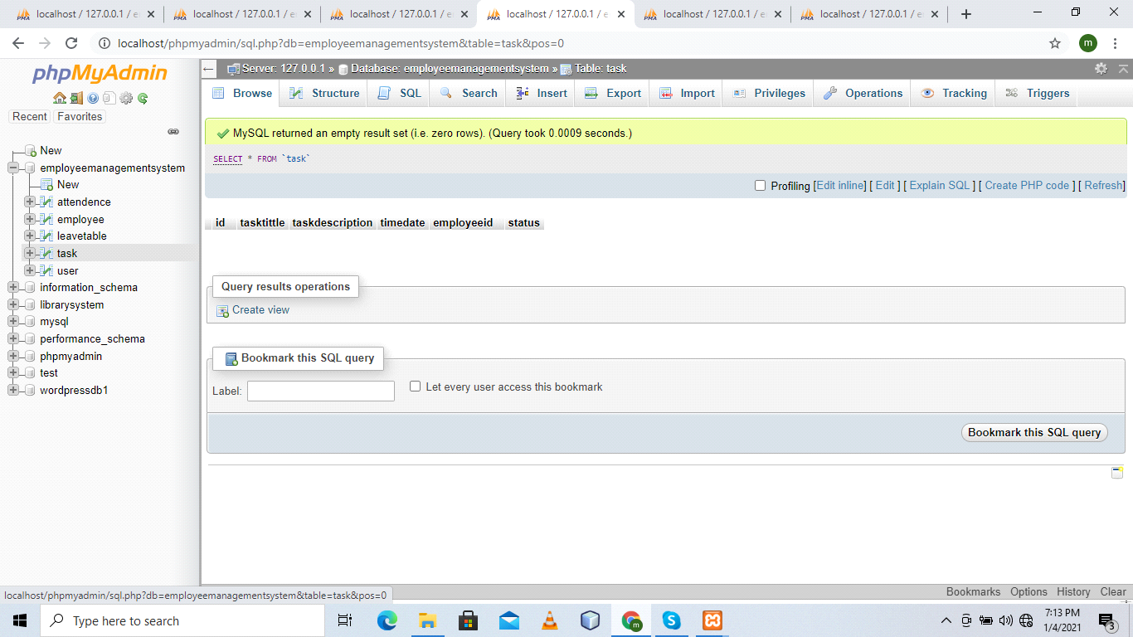

**4.2 Data Dictionary**

**Parameter Parameter Type**

**User:**

id:Int

username**:** String

Email: String

Password String

Email: String

**Employee:**

id: Int

emp_name String

email: String

emp_pic: String

age:String

Gender: String

phone_number String

about: String

time: String

**Leave**

id: Int

e_id: Int

status: String

timetimestamp

**5. COMPONENT DESIGN**

**5.1 Objects and Actions**

|  |  |
| --- | --- |
| **Login** | login screen appear in which Admin enter Id and password if matches then move next page which is homepage. |
| **User** | Log in asked for his requirement |
| **Employee** | In this form employee will be managed |
| **Leave** | In this form leave will be managed |
| **Attendance** | In this form attendance will be managed |
| **Register** | In this Form user can register |
| **Tasks** | In this Tasks will be managed |
|  |  |

**6. HUMAN INTERFACE DESIGN**

**6.1. Overview of the User Interface:**

The functionality of the system will be described from the student’s point of view.

Describe how the user should be able to use the system to perform different operations, features and feedback for the user. In user interface user interact directly with the system through graphical environment.

First login screen appear and user mean act as admin enter the Admin name and password if entered Admin name and password is correct then he can access the system otherwise restricted to the system.

In Home page all menus are shown on the form and user click the register menu to register new student and perform other functions.

**6.2 SCREEN IMAGES**

**6.2.1 Login screen**

* **Interface Design**

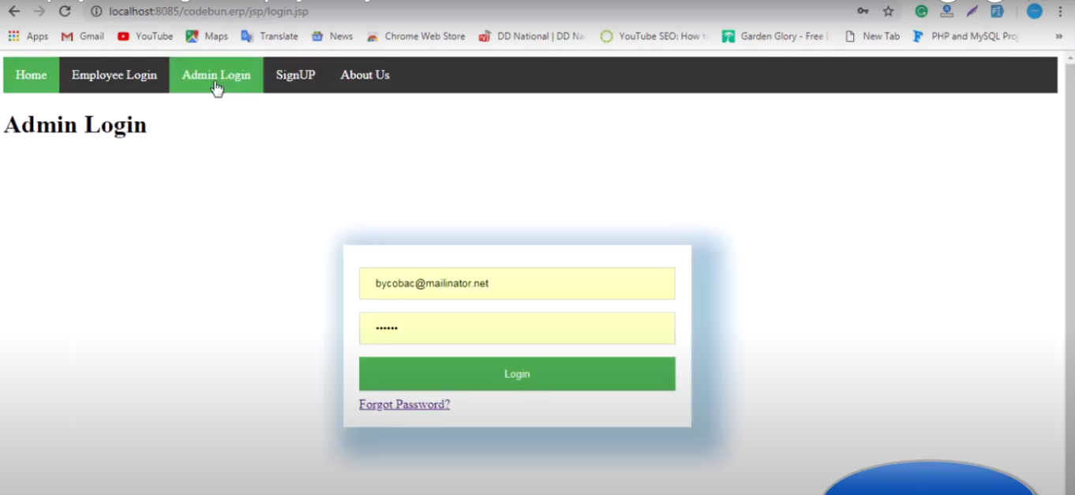

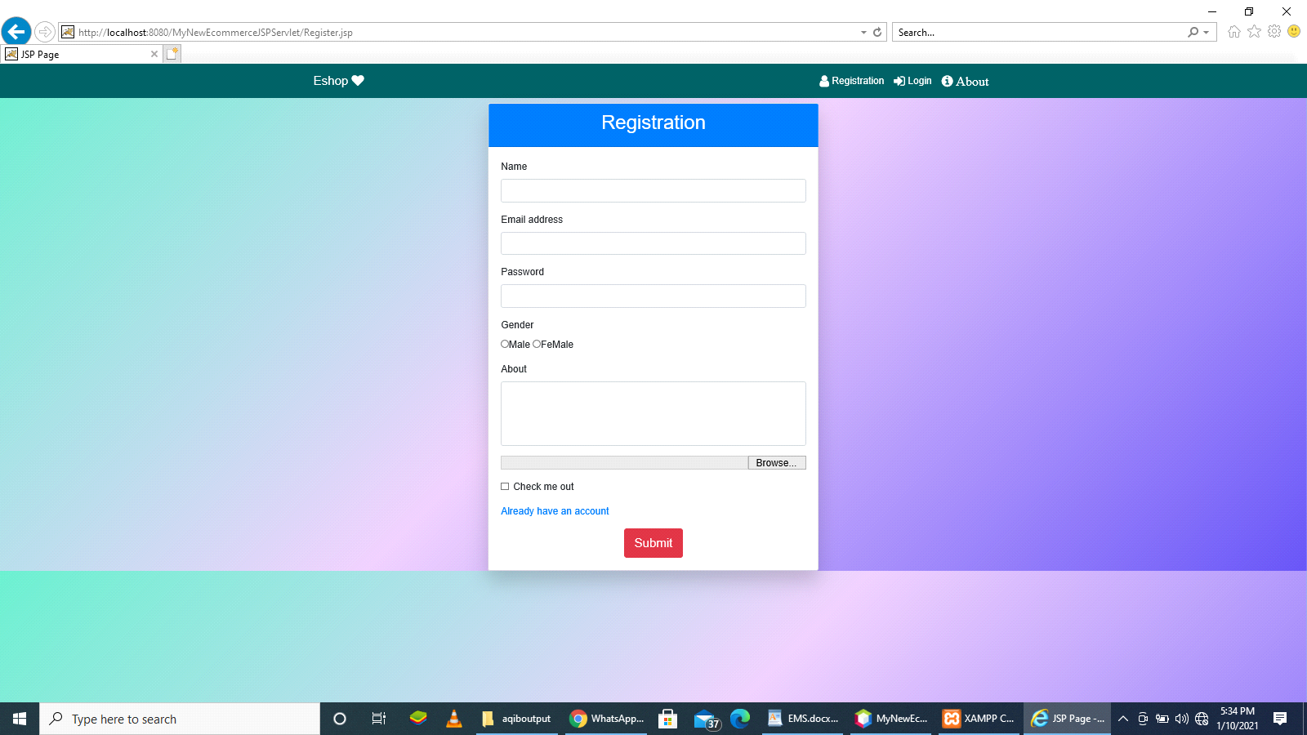

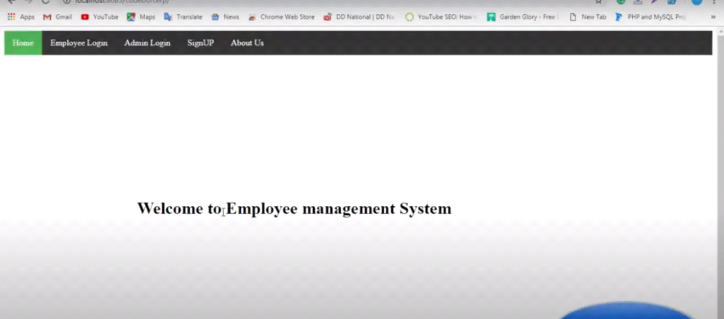

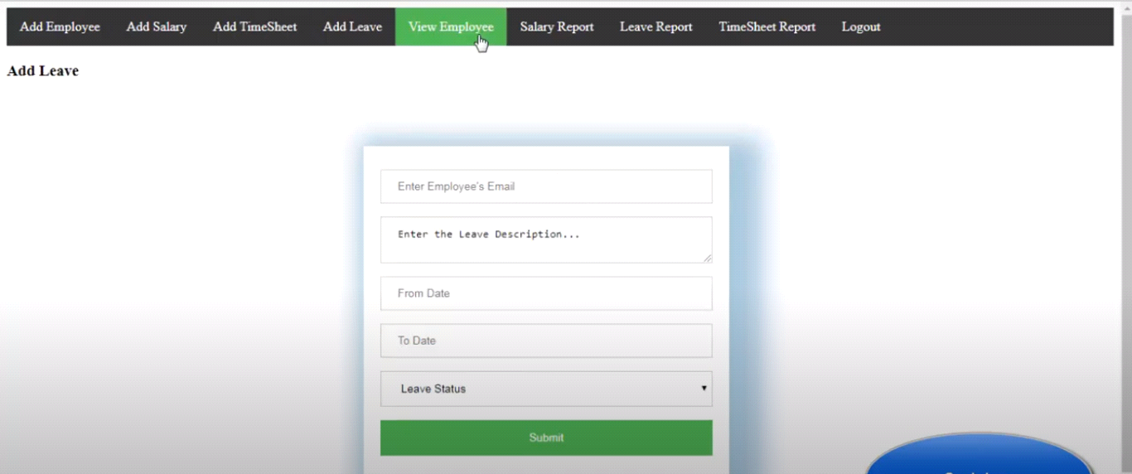

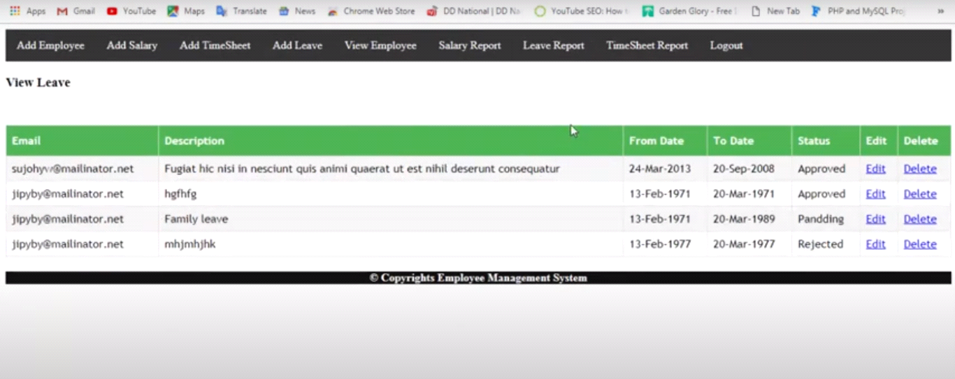

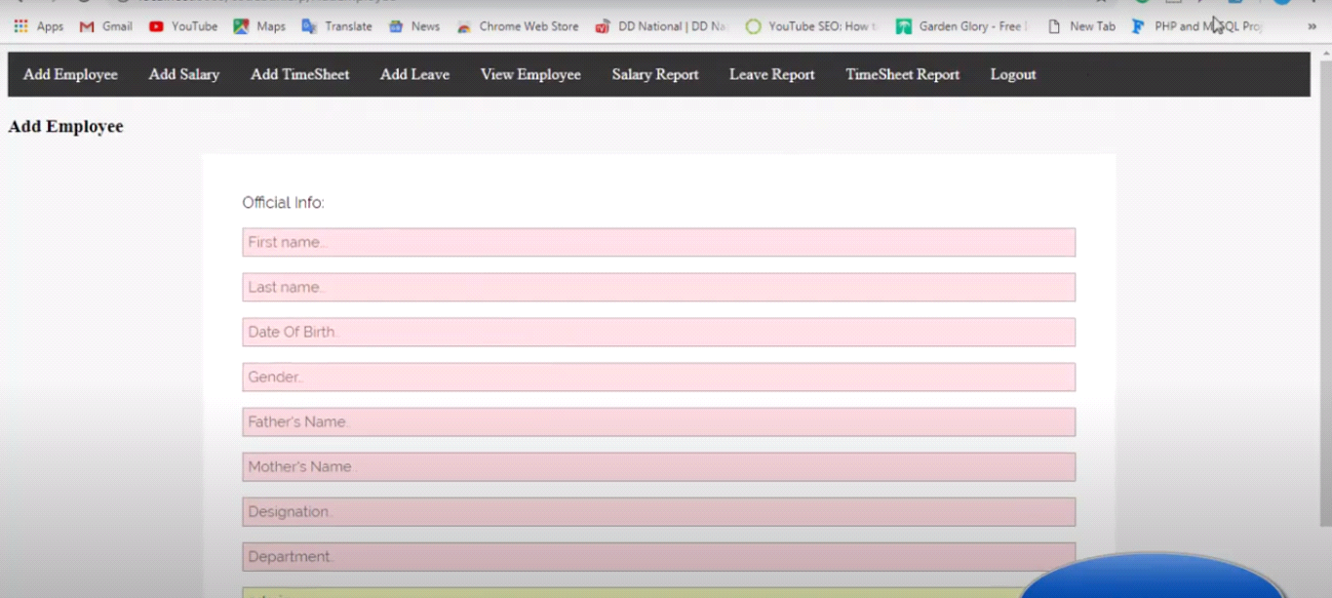

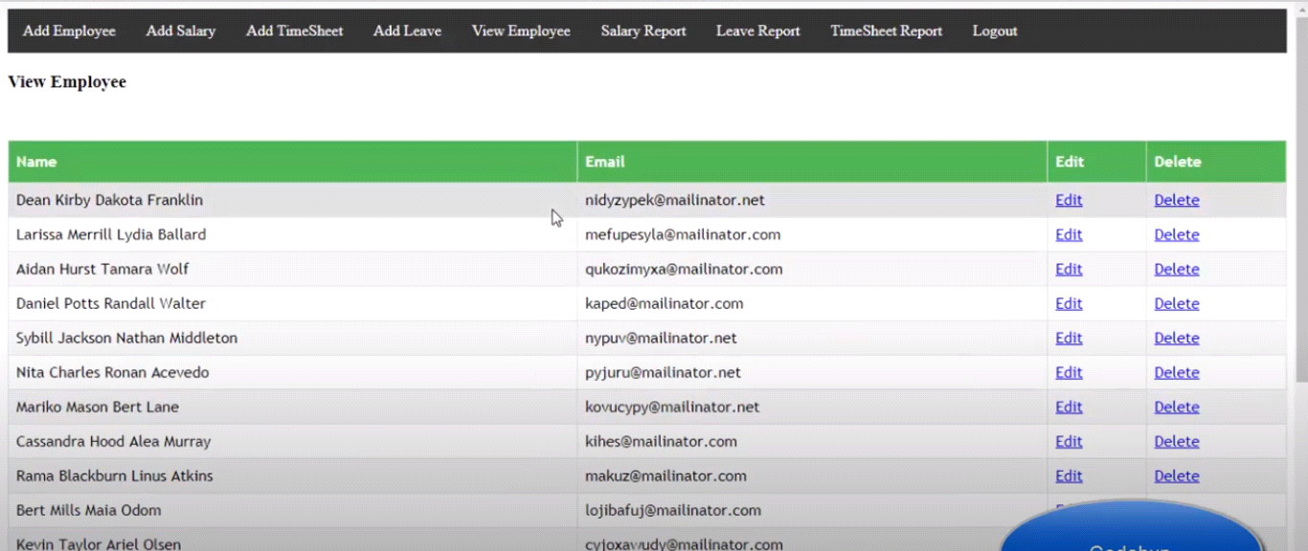

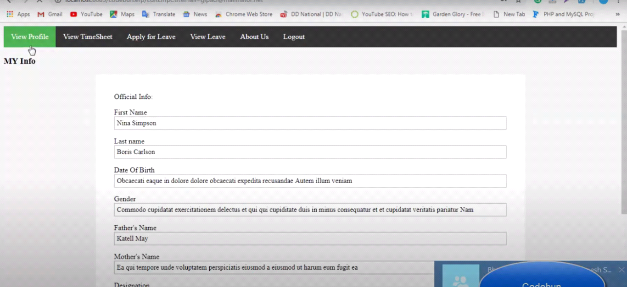



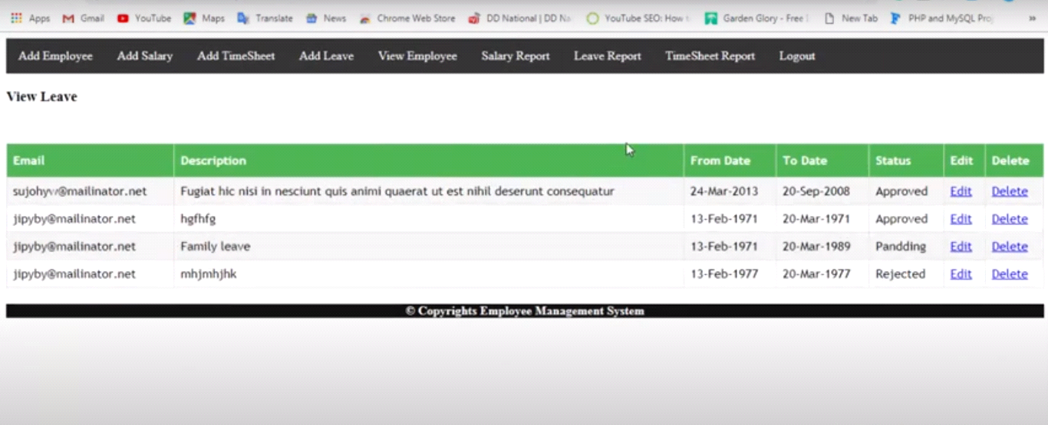

**7. REQUIREMENTS MATRIX**

Help in maintaining the computerized employee details. Calculate the salary. Easy calculation of various leaves in categories. Computerized Events & Requests Management. Create new users to the system accordingly .Because of digital world it would be easy and efficient way of storing and manipulating records of employee in a organization rather than that old manual system which is slow and less efficient.

* **Actor:** It represents a role, an external entity who interact with our system.
* **Use case:** Graphical Represent of interaction among system and actor.
* **Scenario:** The time of actual input and expected output.
* **Use case diagram:** Represent use the services and functionality by the system by the actor.
* **Use case Realization:** How the use case realizes in the design table model.
* **Activity diagram:** Graphical represent of the process flow of use case etc.
* **Sequence diagram:** Represents the interaction of an object to perform a job.
* **Collaboration diagram:** Alternative representation of sequence diagram.
* **Data model:** Represent the persistence object model.

|  |  |
| --- | --- |
| **SRS** | **SDD** |
| SRS is software requirement specification in which we collect the functional requirement and demonstrate how system will work | SDD is software Design Document it is made with the help of SDD how system is represent and how system will design |
| In SRS we collect some techniques like interview. | In SDD the requirement phase is converted in design phase when we collect the requirement. |
| In SRS only we tell how it is work and describe the function of system. | But in SDD we show the data by flow diagram sequence and represent the design graphically how system will work. |